****Year 12 Physics 3AB Circular Motion, Satellites & Torque Test

**/50**

**Name:** __________________________

1. lf you are a passenger on the right side of a car in a left turn you will have the sensation of being thrown against the door. Explain what actually happens to you in terms of the forces and acceleration you

experience.

(3 marks)

2. During bouts of sumo wrestling, the ancient Japanese form of unarmed combat, the contestants stand with their feet wide apart & their knees bent. Clearly explain how this is an advantage to avoid being pushed over.

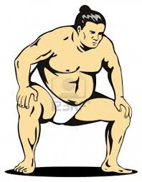

(2 marks)

3. A 70 kg skier is on a frictionless slope. He follows a

Radius 11.0 m

Skier 7.60 m s-1

circular path of radius 11.0 m as he goes over a

mound and has a speed of 7.60 m s-1 at the top of

the circle.

Calculate the normal reaction force he experiences

from the mound at the top of the circle.

(4 marks)

4. By banking the curves of racetracks it is possible for vehicles to turn in a horizontal circle without relying

on friction. For a car of mass 1 700 kg the angle of banking is set at 13.4° above the horizontal. The curve has a radius of 171 m and the car drives at a speed to maintain its height.

Vector diagram

13.4°

1. Draw a vector diagram showing the forces acting on the car and the sum of those forces in the space indicated above.

(1 mark)

1. Calculate the centripetal force acting on the car.

(3 marks)

5. Astronauts can be seen to float around in the space station. Explain why they seem to be experiencing no gravity.

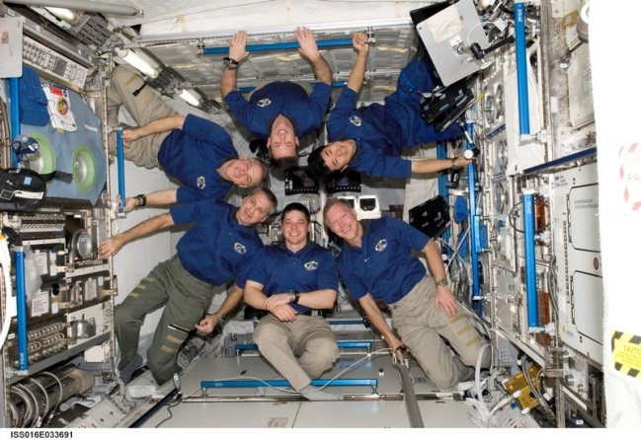

(3 marks)

6. Alice, a 56.0 kg female diving champion, walks to the end of a uniform 25.0 kg diving board.

The board is 6.00 m long and is supported in two places as seen in the diagram below.

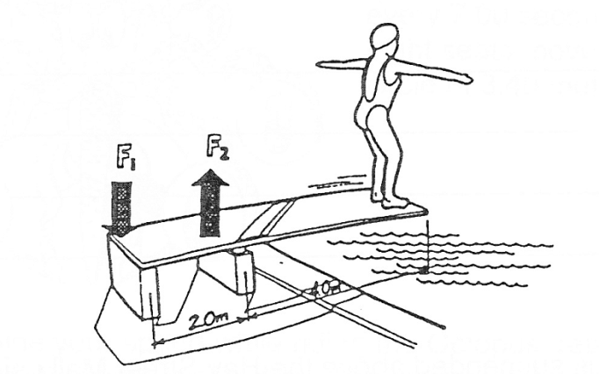

2.00m

4.00m

a) Draw and fully label a vector diagram of this situation in the space below. (2 marks)

b) Determine the force exerted by the supports F1 and F2 for this situation. (3 marks)

7. A roller coaster has a vertical loop of radius 7.00 m as shown. The car starts at rest at a height of 25.0 m.

7 m

25 m

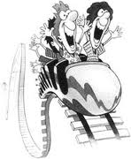

(a) Calculate the speed of the car at the bottom of the loop.

(3 marks)

(b) Calculate the centripetal acceleration at the bottom of the loop.

(1 mark)

(c) Calculate the apparent weight of a 60.0 kg person at that instant at the bottom of the loop.

(2 marks)

8 (a) All satellites, natural and artificial use gravity to keep them in orbit.

Use Fg = Gm1m2 , Fc = mv2 and v = 2πr to derive a relationship between the radius

r2 r T of orbit and the period of orbit.

(2 marks)

(b) The planet Neptune has eight moons, one of which is called Nereid, which orbits at a distance of

5.50 x 109 m from Neptune’s centre. Nereid takes 360 days to orbit Neptune.

Use your work from part (a) to determine the mass of Neptune.

(2 marks)

9. Calculate the tension in the cable and the reaction force provided by the wall on the 1.5 m long beam of mass 1.0 kg holding up a lantern of mass 1.8 kg.

T

40°

1.2 m



1. Marks)

10. A satellite provides information about the receding glaciers on the Earth’s surface. It has a

mass of 395 kg and is in a circular orbit of radius 1.45 x 104 km. By orbiting for 12 days it can

map most of the Earth’s glaciers.

* 1. Calculate the orbital speed of the satellite. (3 marks)
  2. List the force(s) that keep the satellite in its stable circular orbit. (1 mark)
  3. On the diagram below draw one or more **labelled** arrows to show the direction of the

force(s) on the satellite as it orbits the Earth. (1 mark)



(d) Would you expect this satellite to be in a geostationary orbit about the Earth? Explain your answer. (2 marks)



11.







1. Explain how a friction rollover occurs. (2 marks)



(b)

1. Using the information above, ESTIMATE the dimensions h and w for the unloaded and loaded RV and hence calculate its approximate SSF for the unloaded and loaded conditions.

(Hint : use your ruler) (3 marks)

Question 11(b) continued.

1. ESTIMATE the maximum safe speed of the loaded RV around a bend with a radius of 10.0 m.

(3 marks)

End of Test